**How to setup new environment:**

- Order Database server with new ISR  
- Raise an DICA request for port 1433 opening + OpenShift group - REQ100265911  
- Order new Namespace in OpenShift for the new environment. -  
- Set up CICD pipeline refer the existing pipelines:

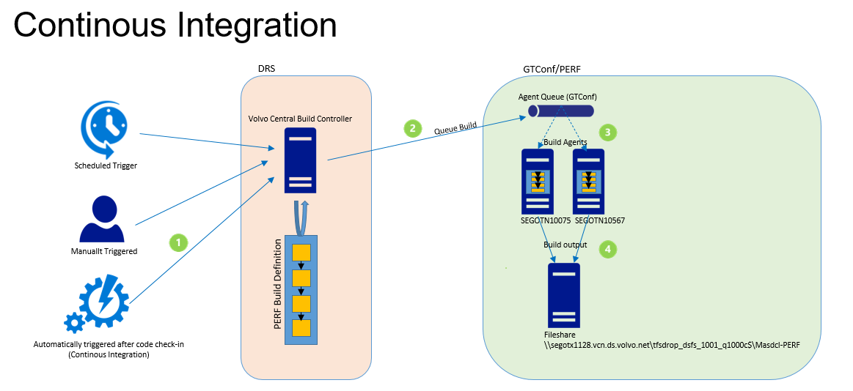

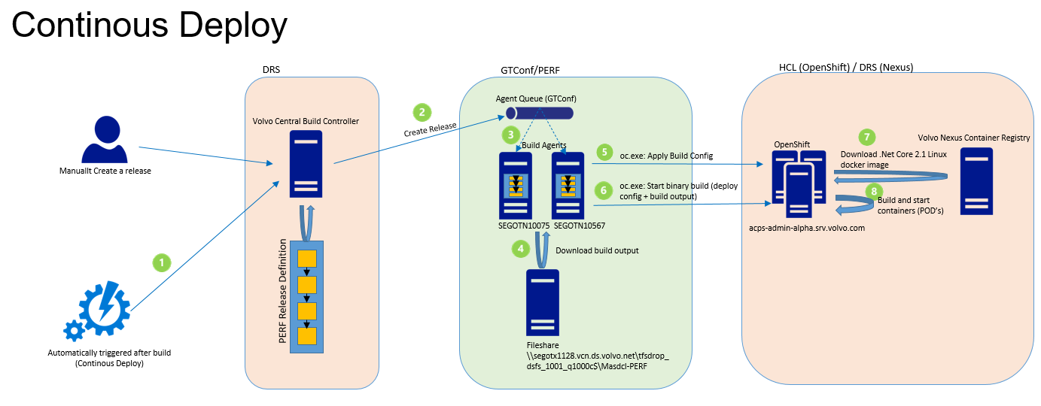

- Order Ping access to generate PA token for new environment  
- REQ100250376  
- Truck Portal setup for new environment  
- Contact Eva

**Application configuration:**

Application structure

Web app

Perf api

Edb external calls

Db’s

Application architecture :

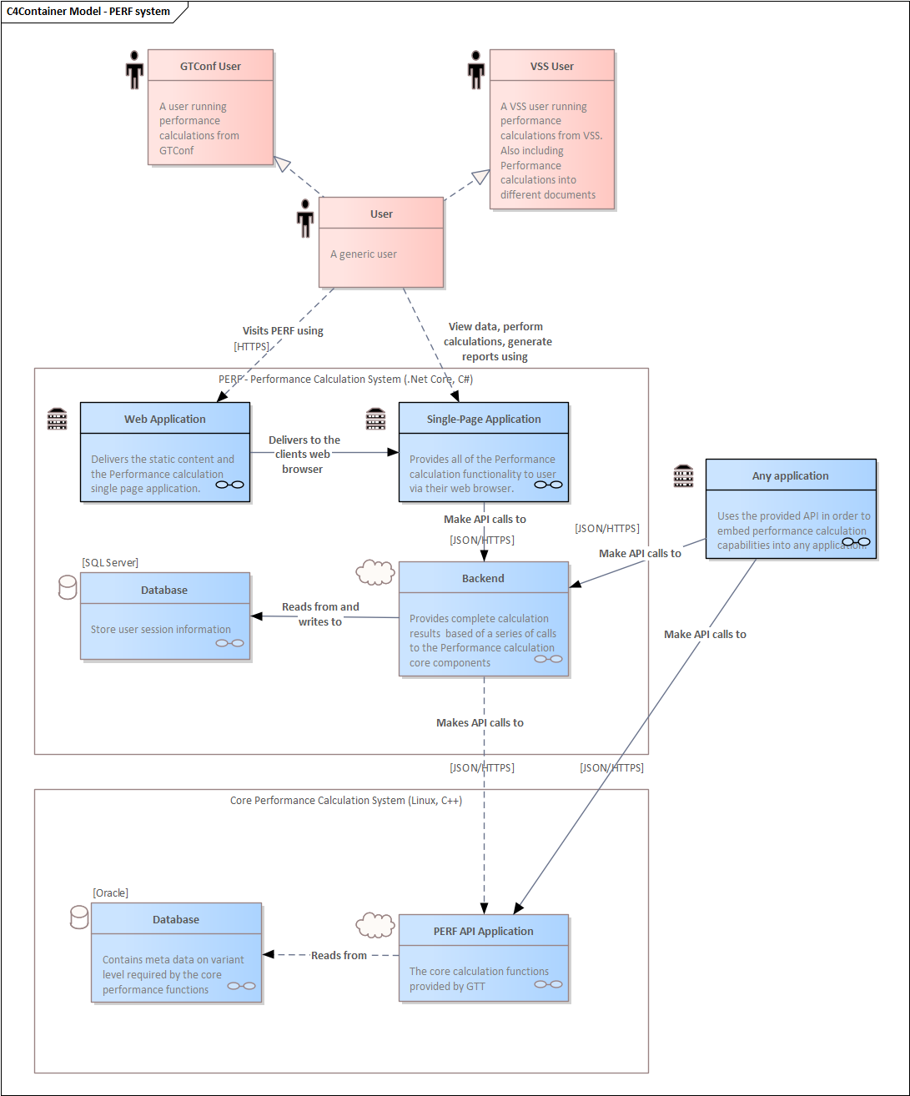

**Continuity Plan:**

**Disaster recovery:**

**Deployment View:**

